QUALIGON QTS Portal manual

Version 2019-11-13

Contents

Access 3

Frontpage 4

Create Users 5

Create Groups 5

Create SIMs 5

Create Mobiles 6

Create Campaigns 7

Assign Users to Groups 7

Assign SIMs to Mobiles 7

Assign Mobiles to Campaigns 7

Assign Groups to Campaigns 7

Define Samples 8

Define Tasks 9

Add device for Testing 11

Changelog 12

# Access

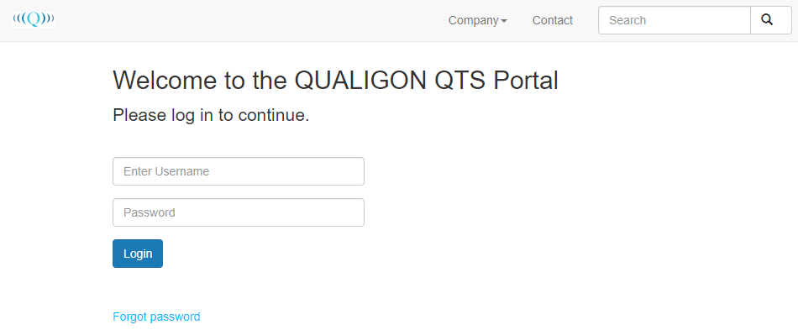

QUALIGON QTS Portal can be accessed via the address <http://test.qualigon.de:8091/login> with the provided credentials. If the Password has been forgotten it may also be reset here.

# Frontpage

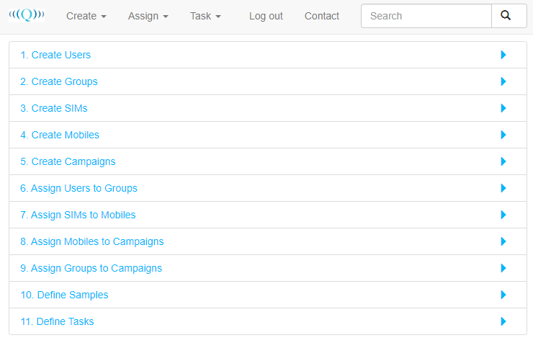

The different actions may either be performed by selecting them from the list or via the Dropdown menus on the Top.

## Create Users

Creates a user for the QTS Portal, assigning the User a Role and a Customer. The Email address provided is used for logging in and can be used to retrieve a new Password via the “Forgot password” function on the login-screen.

Role/Customer are currently not implemented.

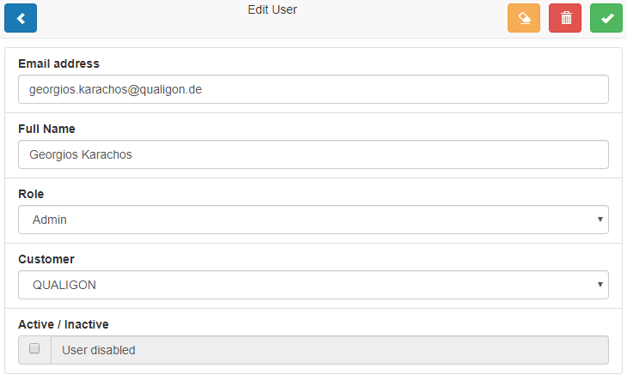

## Create Groups

Users may be assigned to groups

## Create SIMs

Useful for device/SIM management when lots of SIMs are used and often swapped between devices. **Optional**

## Create Mobiles

In order to be able to assign tasks to a mobile it first must be added to the System. Manufacturer and Model are for recognizing devices in QTS, more important are the Unique name and the identifier. For devices with Mobile connectivity (even if no SIM is inserted!) this is the IMEI, otherwise the MAC-Address.

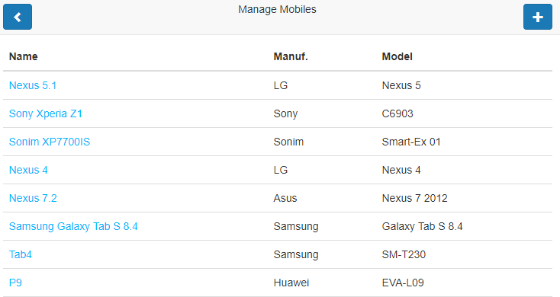

When adding a new Device fill in all available information, most important the Name and IMEI/MAC. For the IMEI enter only the Number, for the MAC please use the format as shown below (UPPERCASE and “:” as a separator).

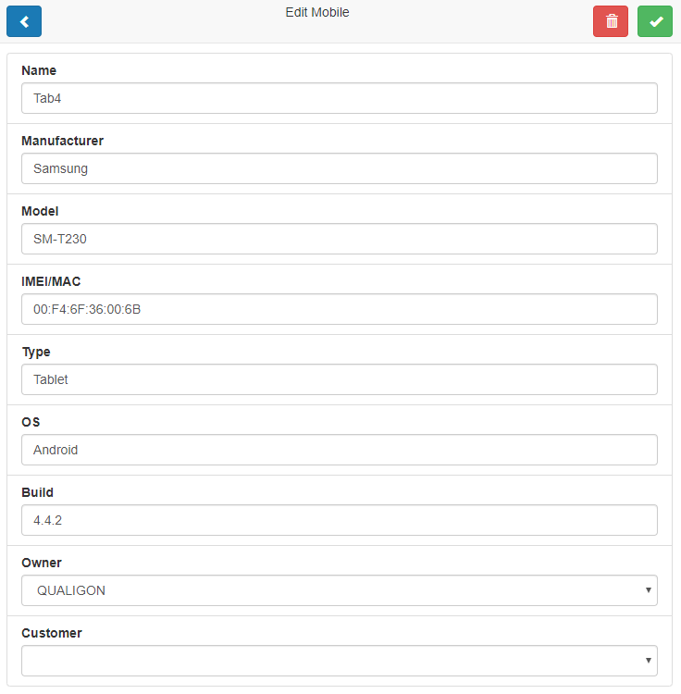

## Create Campaigns

**Non-Functional currently**

## Assign Users to Groups

**Optional**, restrictions based on this are not implemented at present

## Assign SIMs to Mobiles

Useful for device/SIM management when lots of SIMs are used and often swapped between devices. **Optional**

## Assign Mobiles to Campaigns

Assigning a mobile to a campaign is necessary to be able to use the mobile for Tasks in this campaign. Adding/removing is simply done by checking the symbol on the right.

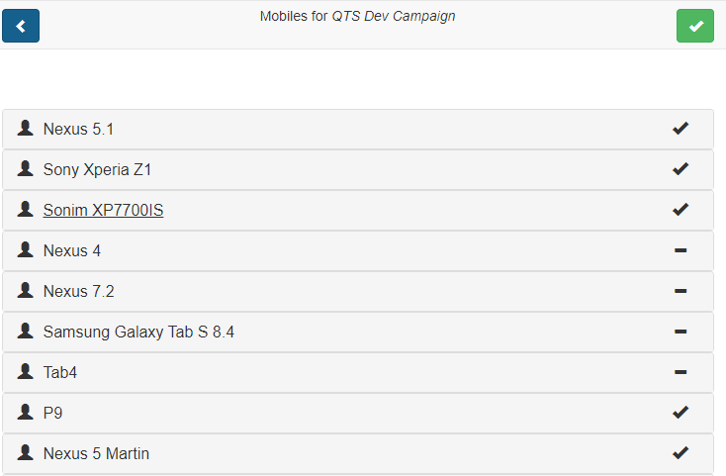

## Assign Groups to Campaigns

Optional, restrictions based on this are not implemented at present

## Define Samples

Administrative, not needed for daily operation. Currently supported by the QTS-App are:

* HTTP File Download Time
* HTTP File Upload Time
* HTTP File Upload Size
* HTTP File Download Size
* Pause
* Ping
* YouTube
* Web Session

## Define Tasks

When defining Tasks first select a Campaign the Task belongs to, then select a Group from Within the Campaign and finally the Task to edit or add a new Task.

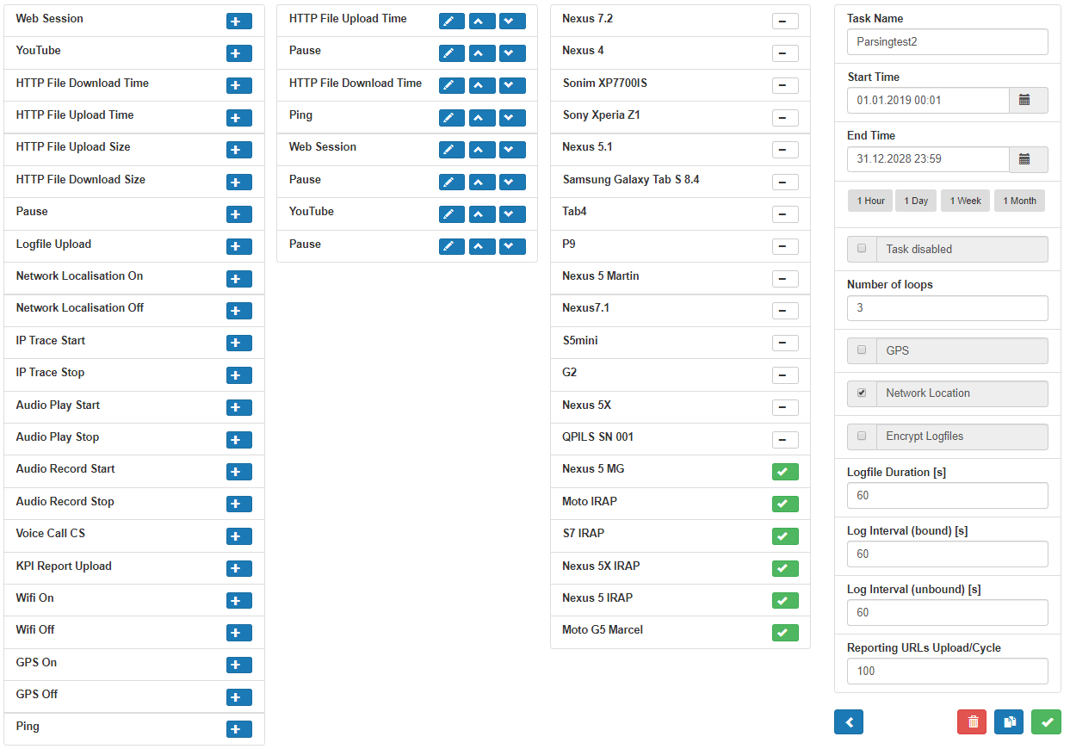

* The First Column contains all available Samples that can be added to the execution in the second Column.
* Tasks may be reordered with the arrow-symbols in the second column or edited by use of the Pen.
* The third Column contains a list of all availabale Devices that can be used to execute the Task.
* The Forth Column contains general settings for this task
  + Task Name
  + Start time
  + End Time
  + Task disabled
  + Number of loops to perform
  + GPS
  + Network location
  + Logging Options (UNSUPPORTED!)

When any changes are made on this page, including changing the assigned devices a new version of the Task will be created, causing all assigned devices to restart testing. This can be used to execute a task again after the requested number of loops has been performed by changing the starttime/endtime slightly (e.g. from 20.12.2012 00:00 to 20.12.2012 00:01)

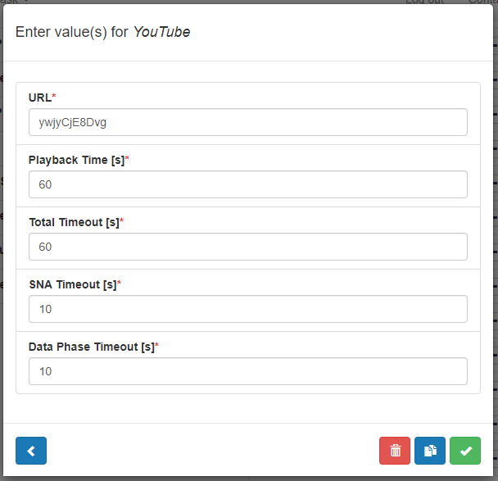When adding a Sample/Editing an existing sample all parameters are displayed and may be edited. Timeouts may be overriden by the app depending on its settings. For example when requesting 30 seconds of youtube playback with a Timeout of 10 seconds and the apps default settings “SAFE_TIMEOUT” it will be changed to 40 seconds in the app, as this is a realistic time to perform the requested actions.

# Add device for Testing

1. Add the Mobile Device to the QTS Portal as described in “Create Mobiles”
   1. Device name should be descriptive
   2. ID can be retrieved from Android app or Device Info
2. Assign the mobile to the “QTS Dev Campaign” as described in “Assign Mobiles to Campaigns”
3. Select the Device as an active device for a task as described in “Define Tasks”
4. Change Time period/Loops as needed
5. Execution on the mobile should start shortly

# Changelog

2019-11-13 Marcel Grotmann Initial release